5-a-side.com’s guide to 5-a-side Rules
These rules have been prepared by 5-a-side.com to assist you in organising your own games, leagues and tournaments. They are provided free of charge, under creative commons, but we ask that you reference 5-a-side.com when using them.
The following list guide has been prepared using the most common rules that are in use in the traditional 5-a-side game. These should be edited according to your individual circumstances. The accompanying notes are designed to provide handy hints and tips to allow you to refine these rules for your own preferences and needs.
Rule | Notes
Pitch and equipment  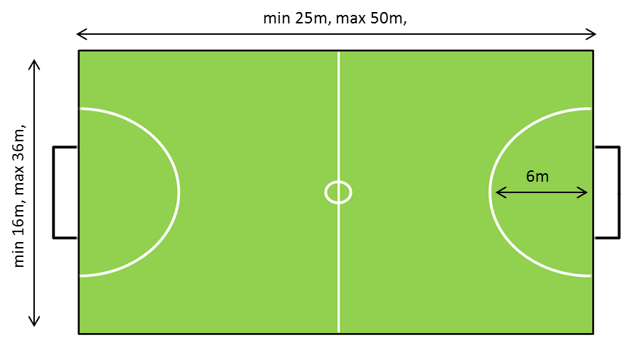  - The ball is a standard size 5 football, the same as is used in the full 11-a-side game.  - Goals used will be standard 5-a-side goals, 12ft (3.66m) by 4ft (1.22m). | You may choose to remove this section from your rules, as the pitch and equipment will be obvious to most players. It is provided here to illustrate recommended pitch dimensions when setting up a pitch.  Suggested measurements are taken per the FA Small Sided football rules. It also recommends a length to width proportion of 2:1.  If playing indoors, a specialist indoor ball may be used.  These “standard sized” goals may be up to 16ft in length, so check measurements.
Game duration  - Games will be a total of __ minutes long, being divided into two equal halves. Teams will change ends at half time. | Insert game time.  Note: Many competitions choose not to divide games into two halves in order to save time changing ends. Our advice is not to bother with a half time if your game is less than 20 minutes long.
Clothing / Attire  - Suitable footwear must be worn at all times. For artificial pitches, blades and long-studded boots are not appropriate. For indoor pitches on hard surfaces, appropriate indoor footwear must be worn and have non-marking soles.  - All players must wear a shirt at all times and teams must make every attempt to ensure that all outfield players play in similar colours. Players must wear bibs where available and instructed by the referee.  - For the safety of all players, all items of jewellery should be removed before entering the field of play, including watches. Additionally, it is required that all players wear shinguards.  - Where not addressed specifically in these rules, judgements over the suitability of player’s equipment are at the discretion of the referee. Players who refuse to remove jewellery; wear shinguards; have inappropriate footwear, or have are wearing attire that is not, in the referee’s view suitable, will be asked to leave the field of play. | Delete artificial pitch / indoor pitch reference as appropriate.
Kick-off  - One team kicks off play for the first half, with the other team kicking off the second half. The referee will determine who takes the initial kick-off, either by coin toss or by a pre-determined schedule.  - All players must be inside their own half for kick-off with the non-kicking players at least 2m from the ball. The ball must be played forward and may not be touched again by the taker until kicked by another player. Players may shoot, and score, directly from the kick-off.  - After a goal has been scored, play will be restarted by the opposing team taking a kick-off from the centre spot. | Remove the first sentence if not playing two halves.  Note: Shooting from kick-off is allowed in the full 11-a-side game, so preserve this rule in 5-a-side.
Goalkeeper  - The goalkeeper is the only player on the field permitted to handle the ball and may do so, only within the area.  - The goalkeeper is not permitted to leave the area and, if found doing so in order to gain an advantage, a penalty kick will be awarded to the opposition.  - Goalkeepers are not permitted to kick the ball, except when making a save. Any infringements of this condition will result in an indirect free-kick 2m outside of the area.  - When distributing the ball, it must be done with the hands, in an underarm bowling motion. Use of an incorrect action, or the ball going over head height even if a correct action is used, will result in an indirect free-kick being awarded to the opposition 2m outside of the area. | Some competitions have chosen to allow goalkeepers to leave the area.  Some competitions have chosen to remove this rule. Ensure it is removed if keepers can come out of their areas.
Pass backs
- A player who has received the ball from the goalkeeper cannot pass it straight back to that player. The ball must touch another player (which may be an opponent) before being passed back.
- If this condition is violated, a free-kick will be awarded to the opposition players 2m outside of the area. This will be the case even if the ball is played directly back into the area and comes to a complete stop without the goalkeeper touching it.

Penalties
- In absence of there being a penalty spot, penalty kicks will be taken in the centre of the pitch, 1 yard back from the edge of the area.
- The goalkeeper must be standing on the line when a penalty is taken.
- The penalty taker must be identified to the referee before the penalty is taken. The penalty taker is allowed one step before striking the ball.
- Where either side has breached these rules to their advantage, the penalty will be re-taken.
Area  - Outfield players are not allowed to enter either area.  - If an attacking player enters the opponent’s area, seeking to gain an advantage, the referee will stop the game and restart play with the goalkeeper. When shooting, the kick must start and finish outside area; if the player’s momentum then carries them forward into the area this will not be penalized unless the player is found to be interfering with the play from a position inside the area.  - If a defending player enters their own area, seeking to gain an advantage, a penalty-kick will be awarded to the opposition team. | Most competitions use this rule, but you may choose to remove it (in which case remove this entire section).
Substitutions
- The referee must be notified whenever there is a substitution of an outfield player. Substitutions require the consent of the referee who will allow the substitution to take place at an appropriate stoppage in the game. The oncoming player must not enter the field until the other player has left.”
- The referee must be notified before any change of goalkeeper takes place. Goalkeepers may only be substituted once during the game, except in the case where a goalkeeper incurs an injury and does not return to the game.
- All substitutes must stand outside the field of play by the access gate, or behind their goals if there are no barriers.

Head height rule  - The ball may not go over head height. Head height is typically deemed to be the height of the tallest person on the field but shall be subject to the judgement of the referee in all cases. Where the ball goes over head height, an indirect free-kick will be awarded against the player who last made contact with the ball, from the position that they made contact.  - As an exception, play will continue if the ball goes over head height as a result of making contact with a goalpost or by a goalkeeper making a save.  - Headers are allowed, provided that they occur within the above rules. | This is a common rule, but it can be removed if desired. If an overhead net or roof is used, consider this alternative wording: “The ball may go over head height. However, where the ball touches the roof of the playing area (or overhead netting) an indirect free-kick will be awarded against the player who last made contact with the ball, from the position that they made contact. As an exception, play will continue if the ball hits the roof as a result of making contact with a goalpost or by a goalkeeper.”
Use of Barriers (where applicable)  - Players must not hold on to the barriers in order to gain advantage. Aggressive play against the barrier will not be permitted.  - Minimal contact should be used against other players against the barriers. Where a player retrieves a ball from the corner, they will be allowed to take the ball out unhindered by the opposition. Players have a maximum of 5 seconds to bring the ball out of the corner; violation of this time limit will result in a direct free kick being awarded to the opposition. | Remove this section if not playing using barriers.
Ball out of play (if using barriers)  - Whilst within the perimeter of the court, the ball is not out of bounds. In the event that the ball leaves the perimeter (other than being kicked over head-height, where such restrictions apply), play shall be restarted with a kick awarded to the appropriate team. This kick is indirect and opponents must be at least 2m from the ball.  Ball out of play (if not using barriers)  - If the ball leaves the playing area along the side line, a roll-in will be awarded, where the player must roll the ball in an underarm action, at the point where the ball went out, to restart play.  - If the ball leaves the playing area along the goal line this will result in either a goal-kick if final contact was had with the attacking team, or a corner kick if the last touch was had by a member of the defending team. Corners shall be taken from the corner spot nearest to where the ball exited play, by way of a kick-in. Opponents must be at least 2m away from the kicker. | Delete as appropriate.
Fair Play
- For the safety of all players, slide tackles are not allowed.
- Violent and aggressive play; unsporting behaviour; and foul and abusive language will not be tolerated. Players exhibiting such behaviour will be penalized by the referee.
- The referee may punish infringements with a yellow or red card. A yellow card will result in the player being sin-binned for two minutes, in which time they may not be replaced by another player. The sin-binned player may only re-enter the field of play when the referee indicates they may do so.
- Where a player is given a red card, they must leave the field immediately and may play no further part in the game. They may not be replaced by another player.
- In the event of persistent or extreme abuse or bad behaviour, the referee has the power to abandon the game which may result in the disqualification of one or both teams from the competition.

Free Kicks
- Players must retreat at least 2m away from where the ball is kicked, for any free-kick.
- If a free-kick is awarded within 2m of the edge of the area, it should be moved back so that it is 2m from the edge of the area, allowing a defensive wall to form in front.
- Failure to retreat the required distance, or in the event of dissent, the kick may be moved forward by two yards. The ball may be moved forward as many times as is necessary where repeated failure to retreat or dissent is shown. If, in moving the kick forward, it would be within the area a penalty-kick may be awarded instead.

Indirect free kicks:
- Ball played over head height
- Goalkeeper not playing the ball underarm
- Player returning the ball directly to the goalkeeper after receiving it from him
- Impeding an opponent

Direct free kicks:
- Kicking, tripping, charging, striking, holding or pushing an opponent.
- Slide tackles
- Handling the ball
- Holding the fences
- Not allowing a player out of the corner

If you found this list useful, or if you have any feedback, we would love to hear from you. You can use our contact us page if you want to get in touch.

